Module 02 – Transportation Modeling

Exploratory Data Analysis

*In this section, you should perform some data analysis on the data provided to you. Please format your findings in a visually pleasing way and please be sure to include these cuts:*

* *The locations involved in the analysis (id -> name) and specify if they are a source or a destination*
* *A table of the average cost between source and destination (for the sake of this assignment, we are dealing with sugar-miles similar to the bushel-mile example from the textbook)*

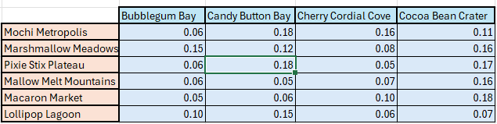

Model Formulation

*Write the formulation of the model into here prior to implementing it in your Excel model. Be explicit with the definition of the decision variables, objective function, and constraints*

Min = .06X15 + .15X16 + .06X17 + .06X18 + 0.05X19 + .10X110 + .18X25 + .12X26 + .18X27 + .05X28 + .06X29 + .15X210 + .16X35 + .08X36 +.05X37 +.07X38 + .10X39 + .06X310 + .11X45 +.16X46 + .17X47 + .16X48 + .18X49 + .07X410

Objective:

X15 + X16 + X17 + X18 + X19 + X110 + X25 + X26 + X27 + X28 + X29 + X210 + X35 + X36 + X37 + X38 + X39 + X310 + X45 + X46 + X47 + X48 + X49 + X410 ≥ 0

Constraints:

X15 + X16 + X17 + X18 + X19 + X110 = 125

X25 + X26 + X27 + X28 + X29 + X210 = 143

X35 + X36 + X37 + X38 + X39 + X310 = 115

X45 + X46 + X47 + X48 + X49 + X410 = 105

X15 + X25 + X35 + X45 ≤ 82

X16 + X26 + X36 + X46 ≤ 88

X17 + X27 + X37 + X47 ≤ 86

X18 + X28 + X38 + X48 ≤ 82

X19 + X29 + X39 + X49 ≤ 83

X110 + X210 + X310 + X410 ≤ 90

Model Optimized for Cost Reduction

*Implement your formulation into Excel and be sure to make it neat. This section should include:*

* *A screenshot of your optimized final model (formatted nicely, of course)*
* *A text explanation of what your model is recommending*

**

The model is essentially showing how much will be produced at a certain location and where this product will be going. So for example Mochi Metropolis is the producer for Bubblegum Bay and Cocoa Bean Crater or Marshmallow Meadows is the only producer for Cherry Cordial Cove.

Model with Stipulation

*Please copy the tab of your original model before continuing with the next part to avoid messing up your original solution. What happens if you add an additional constraint to the model such that all demand MUST be met. Is the solution still feasible? If not, please explain why.*

It Is not Feasible in this case as the demand is not able to be met with Mallow Melt mountains due to there being not enough demand for the amount of units produced in total.